**Short Answer Regents Quiz**

*10 points*

1. Pick one of the following questions to answer: *(2 points)*

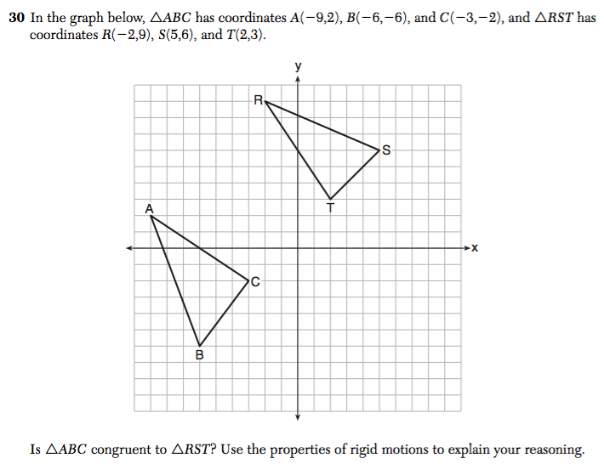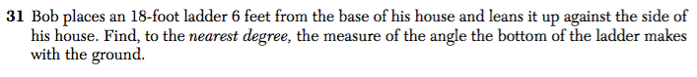

2. Pick one of the following questions to answer: *(4 points)*

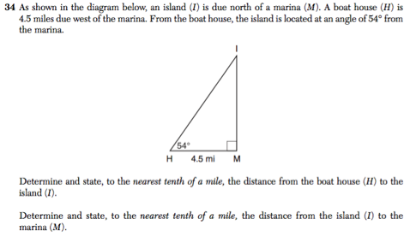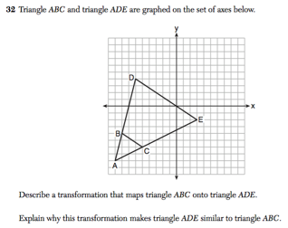

3. What score would you give the following student work for the following question and why ? *(2 points – answer in complete sentences)*

*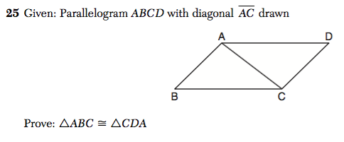  
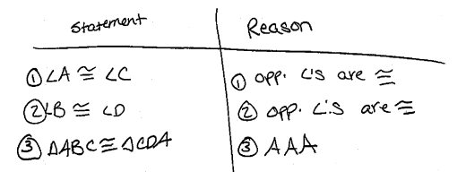*

4. What score would you give the following student work for the following question and why? *(2 points – answer in complete sentences)*

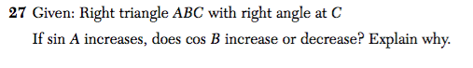

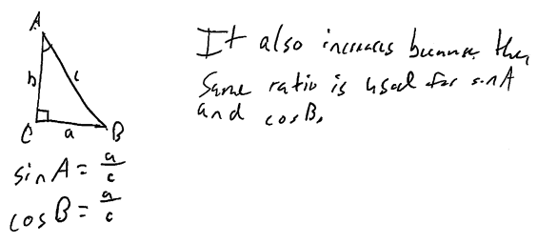

3. What score would you give the following student work for the following question and why ? *(2 points – answer in complete sentences)*

*  
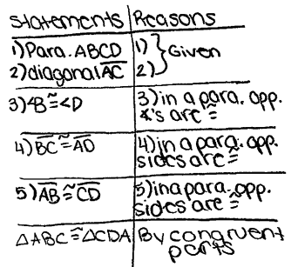*

4. What score would you give the following student work for the following question and why? *(2 points – answer in complete sentences)*

**

